Service and job specific context statement
Directorate: | Central Services
Service: | Support Services
Post title: | Business Support Administrator Level 3 + Additional Duties
Grade: | F
Responsible to: | Business Support Team Leader
Staff managed: | None
Date of issue: | February 2020
Job family: | C&A - Customer & Administration
Job context
- The postholder will work within one of the teams in Employment Support Service. Postholders will be line managed by a Team Leader in Employment Support Service but are expected to use their initiative to respond independently to problems and situations. The teams are set up as follows in the job specifics section with identified responsibilities at this level.
- The post will provide employment support services and guidance across NYCC, its partners and schools. In some instances the postholder may be tasked on a day to day basis by the team leader however there is an expectation to work independently on a project related to the portfolio.
- The postholder may also be responsible for the implementation of some appointments, complex re-structures or the development of new starters within the service, including providing advice guidance and support.
- This role involves spoken communications so a confident use of English language is required.
Job specifics
Payroll processing team – Directorate
- Take the lead on re-structures
- Accountability of all input
- Subject matter expertise in payroll processes
- Provide support and guidance to the team
- Training of new starters
- Project responsibility could include the payroll of one or more Partner and all relevant communications and liaison with the Partner representative/s

Recruitment team
- Provide support and guidance to the recruitment team requiring subject matter expertise in recruitment processes
- Training of new starters
- Monitors workload and allocates work to the recruitment team
- Revises and updates guidance in relation to the recruitment process
- Support the implementation of t Management Board actions
- Spot checking of new starters that are set up by the team
- Lead on senior appointments
- Attendance at meetings where required to feed into changes to processes
- Contribute to 121 meetings

Payroll admin team - Schools
- Have understanding of the wider service
- Lead on the management of all input issues relating to payroll
- Accountability of all input
- Subject matter expertise in payroll transactional processes
- Provide support and guidance to the team
- Training of new starters
- Project responsibility could include the payroll of one or more Academy and all relevant communications and liaison with the Academy representative/s

Salary Sacrifice
- First point of contact for all external providers for payroll processing also liaising with Senior Pay and Reward colleagues
- Lead on all Salary Sacrifice and employee benefit initiatives within ESS
- Accountability of all payroll input for Salary Sacrifice
- Subject matter expertise in Salary Sacrifice processes
- Provide support and guidance to the Schools and Directorate teams
- Training of colleagues on Salary Sacrifice processes
- Attendance at meetings where required to feed into changes to processes
- Processing monthly reconciliation reports
- Processing quarterly governance reports for Pay and Reward Team

Audit team
- Subject matter expertise in payroll processes across the service
- Provide support and guidance to the service
- Spot checking of other team members work and Academy transfers (Grade C, E & F)
- Have an understanding of the wider service
- Attendance at meetings where required to feed into changes to processes
- To undertake and support with high level complex payroll queries and calculations
- Responsible for the induction, and continued support of new starters and provision of refresher training when required.
- Develop and maintain processes and ensure guidance notes are up to date for the service

Structure
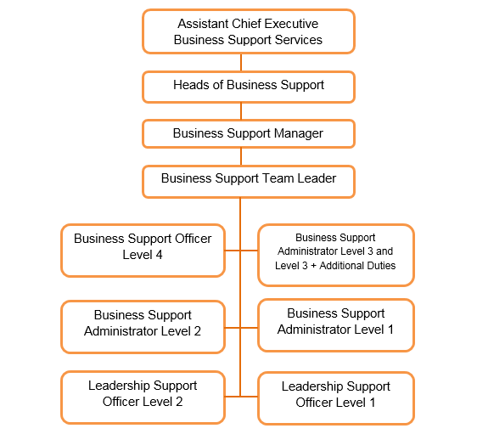
Job Description
Job purpose | The core focus of this post is to provide a wide range of clerical, administrative, financial and/or Directorate specific support to operational services, senior managers and staff some of which may be complex in nature and include specific service working to achieve service aims and targets.
Operational management | - To work to defined business standards and processes; performing a wide range of complex administrative tasks with due regard to confidentiality and safeguarding.  - To provide advice and guidance to customers, business partners across the authority, colleagues within the same service and to schools on processes, protocols and operational service issues which may include dealing with complex queries in relation to corporate initiatives of a high profile or sensitive nature signposting to senior managers on queries relating to varied subjects e.g. maternity arrangements, flexible retirements, overpayments and complex leave queries.  - To create, manage and manipulate data and information with little or no supervision whether relating to finance, staffing information, customers or any other service requirement or eligibility criteria, this will include producing bespoke and complex reports  - Lead, support and guide staff on the implementation of large or complex re-structures  - Create, develop and maintain systems and processes to meet operational needs and to ensure the high quality of information held, which includes the updating of procedural guidance and documentation. This will also include implementation of management board recommendations or changes.  - To ensure relevant statutory, corporate and service deadlines are met for all areas of work including official returns  - Responsible for the organisation of meetings and events including booking venues, issuing invitations and papers and taking minutes.  - Undertake minute taking at high level meetings including disciplinary hearings, statutory meetings, multi- agency meetings and board meetings and provide an accurate record.  - To prepare papers for specialist operational meetings and panels.  - Support team leaders with gathering information in relation to Freedom of Information and Data Protection and Subject Access requests.  - To contribute to the recruitment process, induction and training of new staff and to carry out day to day supervision of staff as required  - Develop and maintain a thorough understanding of wider service areas, corporate initiatives and developments.
Resource management | - Responsible for the induction, and continued support of new starters including having an overview of daily workload and provision of refresher training when required.

Person Specification
Essential upon appointment | Desirable on appointment
Knowledge  - Knowledge of relevant specialist area as outlined on the context statement.  - Knowledge of business processes and operational issues relevant to the position.  - Knowledge of relevant NYCC policies and procedures including those relating to safeguarding, data protection and confidentiality  - Good understanding and commitment to high quality services and customer care | - Knowledge of working to statutory and legislative standards relevant to the position.
Experience
- Experience of providing the day to day support to services, partners and providing business support in a busy environment
- Experience of data input and data management ensuring accuracy and where appropriate confidentiality
- Significant experience and competence using IT and common business support packages including word processing and spreadsheets
- Experience of note and minute taking
- Experience of providing information to the public or customers using good communication skills
- Experience of using defined business processes and giving guidance on them to colleagues
- Experience of working to statutory and legislative standards where appropriate.
- Experience of managing and prioritising own workload
Occupational Skills
- Ability to process and monitor financial information
- Ability to communicate effectively in writing to produce documents in a range of formats and style to suit a range of audiences
- Customer-facing role requiring the ability to converse at ease with customers and provide advice in accurate spoken English is essential for the post
- Ability to set up filing systems and to store, retrieve and archive information
- Ability to produce a representative record of meeting discussion and actions.
- Ability to analyse, organise and present numerical data.
- Good literacy and numeracy skills
Professional Qualifications/Training/Registrations required by law, and/or essential for the performance of the role  - Level 3 qualification in Business Administration or equivalent or willingness to work towards qualification  - Good literacy and numeracy skills to Level 2 or equivalent  - Commitment to ongoing development | - First Aid qualification
Other Requirements
- Able to attend occasional meetings outside of normal business hours
- Ability to travel around the County and willingness to work flexibly including evening and weekends (only essential for some posts).
Behaviours | Link
NB – Assessment criteria for recruitment will be notified separately.
Optional - Statement for recruitment purposes: You should use this information to make the best of your application by identifying some specific pieces of work you may have undertaken in any of these areas. You will be tested in some or all of the skill specific areas over the course of the selection process.

